***Chapter1***

**INTRODUCTION**

In today’s rapidly evolving academic landscape, feedback from students plays a crucial role in ensuring the quality of education and services provided by institutions. Colleges and universities are increasingly recognizing the need to collect, analyze, and act on feedback from students in order to continuously improve academic programs, faculty performance, administrative processes, and campus facilities. Feedback mechanisms are not only essential for maintaining academic standards but also for fostering a culture of transparency, accountability, and continuous improvement.

**1.1 Background**

Traditionally, feedback in educational institutions has been collected through paper-based surveys administered at the end of a semester or academic year. While this method provides some insight into student perspectives, it is fraught with limitations such as low response rates, manual processing overhead, delayed analysis, and a lack of anonymity. Additionally, paper-based systems are not scalable, especially in institutions with large student populations, and they offer limited scope for dynamic question changes or personalized feedback collection.

With the increasing digitization of educational services, there is a growing demand for automated and intelligent systems that can simplify and streamline feedback collection. Online feedback systems offer numerous advantages over traditional methods, such as real-time data collection, faster analysis, improved accuracy, greater reach, and enhanced privacy. These systems can be integrated into existing institutional portals or learning management systems (LMS), allowing students to provide timely and meaningful feedback through smartphones, tablets, or computers.

This project proposes the development of an Online Feedback Form System for College Departments, which is designed to address the inefficiencies of traditional feedback mechanisms. The system will provide a user-friendly interface for students to submit feedback on faculty members, courses, and facilities, while allowing administrators to access real-time reports and insights. This ensures that timely interventions can be made to improve teaching quality and student satisfaction

In the age of digital transformation, educational institutions are undergoing a paradigm shift in the way they manage academic processes and interact with students. Among the most crucial components of academic quality assurance is the collection of student feedback. This feedback is not merely a formal exercise but a vital mechanism through which colleges and universities gauge the effectiveness of teaching, curriculum design, infrastructure, and administrative services. In this context, feedback serves as a bridge between students and faculty, ensuring that the academic environment is continuously evolving in response to learners' needs and expectations.

Historically, colleges have relied heavily on paper-based feedback systems. At the end of each semester or academic year, students are asked to fill out standardized forms evaluating their teachers, courses, laboratories, and campus facilities. While these methods have functioned adequately for decades, they present numerous drawbacks. Manual feedback collection is not only time-consuming and error-prone but also logistically complex when dealing with large student populations. Processing thousands of paper responses requires significant manpower, which introduces delays and risks of data loss or inaccuracies. Furthermore, students are often reluctant to provide candid responses due to concerns about anonymity or repercussions, especially in systems where identity can be inferred from handwriting or roll numbers.

The evolution of technology in educational institutions has created opportunities to reimagine traditional systems. With the widespread availability of the internet, smartphones, and cloud computing, online platforms have become the new standard for communication, learning, and administration. This digital shift has prompted institutions to explore more efficient, accessible, and scalable feedback systems. An online feedback form offers multiple advantages over conventional paper-based systems. Students can submit feedback from anywhere at their convenience, which encourages participation. The feedback data can be stored securely, processed automatically, and analyzed in real-time. Moreover, digital systems ensure better privacy and anonymity, allowing students to express their honest opinions without fear of judgment or retaliation.

The need for such an online system has become particularly urgent in recent years due to the rapid growth in student enrollments, diversification of academic programs, and rising expectations for quality assurance from accreditation bodies and stakeholders. National and international education accreditation councils, such as NAAC (National Assessment and Accreditation Council) in India or ABET (Accreditation Board for Engineering and Technology) in the United States, emphasize the importance of systematic and transparent feedback collection mechanisms. These bodies often require detailed analytics on student satisfaction, teaching effectiveness, and infrastructure utilization as part of institutional evaluation. A robust online feedback form system can help educational institutions meet these compliance requirements while also improving the overall learning experience.

**1.2 Problem Statement**

Despite being one of the most critical mechanisms for institutional growth and academic quality assurance, student feedback in many colleges remains underutilized, outdated, or inefficiently managed. Institutions often rely on manual, paper-based methods of collecting feedback at the end of each semester, which are prone to numerous shortcomings and operational bottlenecks. These outdated systems hinder the effective collection, interpretation, and use of student opinions that are essential for making improvements in pedagogy, facilities, administration, and the overall educational experience.

One of the fundamental problems with traditional feedback systems is their lack of efficiency and responsiveness. Paper-based forms require significant effort in terms of printing, distribution, collection, and manual data entry. The entire process is time-consuming, often stretching over weeks or months. This lag severely reduces the usefulness of the feedback, as the faculty or administration typically reviews it long after the academic session has ended. Consequently, corrective actions if taken come too late to benefit the students who provided the feedback in the first place.

Equally concerning is the low participation and engagement from students. Many students view feedback forms as a formality rather than a meaningful activity due to their repetitive format, lack of personalization, and perceived ineffectiveness. When students feel that their feedback is not acknowledged or acted upon, they become disengaged, leading to poor response rates and non-representative data. Moreover, paper-based feedback mechanisms do not guarantee anonymity, which discourages students from being completely honest especially when evaluating faculty members. The fear of identification or repercussions can skew responses, making the collected data biased or superficial.

There are also logistical and operational challenges associated with the conventional system. Large departments with hundreds or thousands of students face major difficulties in coordinating paper distribution, ensuring form completion, and compiling results manually. Different courses may require customized questions, and managing multiple templates becomes cumbersome. Additionally, infrastructure limitations such as the lack of digitized storage, staff shortages for data entry, and no central repository for feedback records make it virtually impossible to track historical trends or generate comparative reports across semesters.

Another core issue is the lack of actionable insights from collected data. Even when data is gathered, traditional systems typically do not support visual analytics or interactive dashboards. Academic committees may receive raw data or basic average scores without deeper analysis. Without automated reporting, heat maps, or category-wise breakdowns, institutions miss the opportunity to identify patterns, areas of concern, or high-performing courses/faculty. In an era where data-driven decision-making is crucial, the absence of such analytical capabilities is a major limitation.

In addition to functional shortcomings, compliance and audit requirements from accreditation bodies and internal quality assurance cells (IQAC) are becoming more stringent. Regulatory authorities like NAAC, NBA, and UGC often require digital evidence of student feedback, actionable summaries, and data transparency. Manual systems fall short of these expectations, resulting in compliance risks and poor institutional grading during evaluations. This creates a growing need for a structured, traceable, and standards-compliant feedback system that can demonstrate institutional accountability.

The current landscape has also changed drastically post-pandemic, where online and hybrid learning environments have become the norm. In such settings, traditional feedback forms are no longer practical or even possible. Students attend classes from remote locations, and distributing physical forms is infeasible. This shift to digital education has amplified the urgency for a cloud-based or web-accessible feedback system that can function regardless of physical location, time zone, or device. Institutions that fail to adapt risk alienating students and losing visibility into the effectiveness of their evolving academic delivery models.

All of these challenges culminate in a critical gap between student experience and institutional responsiveness. Without timely, accurate, and actionable feedback, educational institutions cannot make informed decisions regarding teaching methodologies, course design, or resource allocation. The failure to modernize feedback systems results in wasted academic opportunities, unaddressed student grievances, and a potential decline in educational quality. It also damages the relationship between students and faculty, as there is no transparent channel for dialogue or improvement.

**1.3 Objectives**

The primary objective of the Online Feedback Form System for College Department is to design and implement a web-based platform that modernizes, automates, and enhances the process of collecting and analyzing student feedback in academic institutions. The system aims to address the critical shortcomings of traditional, paper-based methods by providing a digital, efficient, and user-centric alternative. In doing so, the project supports the larger institutional goals of quality assurance, continuous improvement, and transparent academic governance.

At the most fundamental level, the system is intended to enable students to submit structured feedback on various academic and administrative aspects of their college experience ranging from faculty teaching effectiveness and course content to laboratory facilities and classroom infrastructure. This feedback will be collected through dynamic digital forms, processed in real-time, and presented to the respective stakeholders such as department heads, faculty members, and administrative officials through a user-friendly dashboard interface. The goal is to convert raw feedback into actionable insights that can guide policy changes, pedagogical improvements, and resource allocation decisions.

One of the core objectives is to ensure timeliness and efficiency in feedback processing. The proposed system will eliminate the delays associated with manual collection and analysis of feedback data. Through automated form submissions and database integration, the system will instantly compile responses, calculate scores, and generate visual summaries. This immediate availability of data allows stakeholders to intervene quickly and effectively, whether it involves addressing student concerns, recognizing exceptional teaching performance, or upgrading facilities based on student input.

Another major objective is to ensure anonymity, fairness, and inclusivity in the feedback process. A critical barrier in traditional systems is the reluctance of students to provide honest feedback due to fear of being identified or targeted. This project will ensure complete anonymity for student responses, thereby fostering a safer environment for candid expression. The system will not collect personally identifiable information unless explicitly required for specific contexts, and even then, it will maintain strict access controls. Furthermore, the platform will be designed to be accessible to all students, including those with disabilities or those studying in remote or rural locations, thereby ensuring that no voice goes unheard.

From a technical perspective, one of the key objectives is to create a modular and scalable architecture that can be easily adapted for use across different departments, programs, or institutions. The system will allow administrators to configure and customize feedback forms with various question types such as ratings, text comments, multiple-choice questions, and Likert scales. This customization capability is essential for catering to the unique feedback requirements of diverse academic disciplines, such as engineering, arts, science, or commerce. For example, a laboratory-intensive engineering course may require feedback on technical equipment, while a humanities course may focus more on lecture delivery and student engagement.

A significant long-term objective is to facilitate data-driven decision-making and continuous improvement through intelligent analytics and reporting tools. The system will include features to generate graphical reports, comparison charts, trend analyses, and department-wise summaries. These insights will empower academic leaders to evaluate performance over time, identify problem areas, and prioritize interventions based on evidence. For instance, a recurring decline in faculty feedback scores in a particular subject area may indicate the need for pedagogical training or curriculum updates. Likewise, consistently high ratings may serve as a benchmark for best practices that can be replicated across departments.

In addition, the project also aims to support role-based access and secure multi-user environments. Users such as administrators, department coordinators, and faculty members will have access to specific parts of the system based on their roles. For example, a Head of Department (HoD) can view aggregated feedback for all faculty members under their purview, while individual instructors can access feedback related only to their own courses. Administrative staff can manage form schedules, user credentials, and system configurations. This granular control ensures that the system maintains academic integrity while offering flexibility for different use cases.

Another crucial objective is to design a system that is compliant with institutional data policies and regulatory standards. As accreditation bodies such as NAAC, NBA, and UGC increasingly demand transparency and accountability in academic processes, having a digital feedback system that logs, archives, and reports data in a standardized format becomes vital. The system will incorporate features like secure login, time-stamped submissions, exportable reports, and an audit trail, ensuring that feedback data can be validated and verified for internal assessments or external audits.

In the broader institutional context, one of the aspirational objectives is to improve academic quality and student satisfaction across departments by making feedback a continuous, iterative process rather than a once-a-semester obligation. With the proposed system, departments can roll out mid-semester feedback, instant course evaluations, or event-specific feedback forms to gather targeted insights. This makes the feedback process dynamic and responsive rather than static and reactive. Students, in turn, feel more engaged and valued, knowing that their opinions are being heard and acted upon promptly.

**1.4 Scope of the Project**

The scope of the Online Feedback Form System for College Department outlines the functional boundaries, targeted users, operational limitations, and envisioned capabilities of the proposed system. It establishes what the project aims to achieve, how far it will go in addressing institutional needs, and what constraints define the initial implementation. By clearly defining the scope, stakeholders can align their expectations, ensure targeted resource allocation, and develop a realistic roadmap for system deployment and enhancement.

The primary scope of this project is to design, develop, and deploy a web-based feedback collection platform specifically tailored for college departments. This platform will serve as a centralized system where students can securely and anonymously provide feedback on various academic and institutional aspects, including faculty teaching quality, course relevance, lab resources, classroom infrastructure, and overall satisfaction. The system will be accessible through a web browser on any device desktops, laptops, tablets, or smartphones without requiring any specialized software installation. The project will focus on ensuring ease of access, simplicity of use, and reliability in collecting and storing student responses.

From a functional perspective, the system will support the creation of dynamic feedback forms with customizable question sets. Different departments or programs can configure their feedback forms independently, allowing for discipline-specific evaluations. For example, a Computer Science department may include questions on lab software availability, while a Commerce department may focus on practical exposure or teaching aids. Each feedback form can contain a combination of rating scales (e.g., 1 to 5 stars), dropdown selections, text inputs for open-ended responses, and Likert-scale opinion options. The system will be designed to support multiple feedback categories, such as mid-semester feedback, end-semester faculty evaluation, course-specific forms, and infrastructure-related surveys.

The scope also includes the development of role-based modules. These include the Student Module, Admin Module, and optionally a Faculty Module. The student module will provide authenticated access for learners to fill out feedback forms anonymously. The admin module will allow department heads or feedback coordinators to configure forms, schedule feedback windows, manage user access, and generate reports. In a future-enhanced version, faculty members may have access to summary reports of feedback related to their courses, enabling them to reflect on performance and address concerns proactively.

A key element within the project’s scope is the data analytics and reporting module. Once feedback data is collected, the system will process it using built-in statistical tools to generate summaries and visualizations. Administrators will be able to view average scores, identify trends over time, compare departments or subjects, and download PDF or Excel reports. These insights will not only support internal quality improvements but also serve as evidence for accreditation and compliance audits conducted by bodies such as NAAC or NBA.

On the technical side, the project scope covers the use of standard web development technologies such as HTML, CSS, JavaScript for frontend, and PHP for backend development. The data will be stored using MySQL or MongoDB, depending on the required data structure. Authentication and access control will be handled through secure login systems, and the platform will include mechanisms to prevent duplicate submissions or spam entries. The project will also ensure compatibility across major browsers (Chrome, Firefox, Edge) and responsive design for use on mobile devices.

Importantly, the scope defines what is not included in the initial version of the project. The system will not include features such as AI-driven sentiment analysis, mobile app deployment, chatbot integration, or live notifications to students. It will not interface directly with external Learning Management Systems (LMS) or third-party applications such as Google Forms or Microsoft Power BI dashboards. The system will not perform deep analysis on open-ended responses beyond text capture. However, the underlying architecture will be built with modularity and scalability in mind, so that such advanced features can be added in future iterations without the need for complete redesign. From an academic standpoint, the project serves not only as a working solution but also as an educational demonstration of how technology can be applied to solve real-world challenges in academic governance.

**1.5 Methodology Overview**

The development of the Online Feedback Form System for College Department follows a structured and phased methodology that integrates both software engineering best practices and academic research principles. Given the critical role of feedback in maintaining educational quality, it is essential that the system be built systematically to ensure functional completeness, security, scalability, and usability. The adopted methodology reflects a modified Agile Software Development Life Cycle (SDLC), which allows for iterative development, frequent testing, and stakeholder feedback at every stage. This approach supports flexibility in accommodating evolving requirements while ensuring disciplined progress toward system objectives.

The project begins with a requirement gathering and analysis phase, where the needs of various stakeholders—students, faculty, and administrators—are identified through interviews, observation, and review of existing manual processes. This phase establishes the core functional requirements such as feedback form generation, anonymity handling, data storage, reporting, and system access controls. Non-functional requirements such as performance, security, and browser compatibility are also documented. Based on the findings, a detailed requirement specification document is created to guide the rest of the project lifecycle.

Following the requirements phase, the project moves into system design and architecture planning. During this stage, key design decisions are made regarding the frontend and backend technologies, database schema, and system flow. The system is divided into modules—such as student login, feedback form generation, form submission, and admin reporting—each designed to operate independently but in an integrated manner. Entity Relationship Diagrams (ERDs), Data Flow Diagrams (DFDs), and Use Case Diagrams are prepared to visually represent the structure and behavior of the system. The architecture is designed to follow a three-tier model, separating the presentation layer (UI), application logic layer (server-side code), and data layer (database), which ensures maintainability and scalability.

The next stage is frontend and user interface (UI) development. Using technologies such as HTML5, CSS3, JavaScript, and optionally Bootstrap or Tailwind CSS, a clean, responsive interface is designed. The goal is to create a system that is intuitive enough for students from any academic background to use with minimal instruction. The UI includes pages such as login, dashboard, feedback form, submission confirmation, and administrative analytics. Special attention is paid to form design—questions are arranged clearly, inputs are validated in real-time, and feedback categories are segmented for ease of use. The user interface is also tested on multiple screen sizes and browsers to ensure cross-platform compatibility.

In parallel, the backend development is carried out using robust and secure frameworks such as PHP with Laravel, Python with Flask/Django, or Node.js with Express, depending on the team’s technology preference. The backend handles server-side logic, including student authentication, form submission validation, feedback score computation, anonymization of responses, and report generation. RESTful APIs are designed to allow seamless communication between the frontend and backend components. Each module is developed independently and tested thoroughly before being integrated into the main system.

For data storage, a structured database is implemented using MySQL or MongoDB, depending on the nature of the data. MySQL is preferred for relational structures where tables such as students, courses, feedback_questions, responses, and reports are interconnected via primary and foreign keys. In contrast, MongoDB is suitable for storing semi-structured or dynamic data such as responses to open-ended questions. Proper indexing and normalization are implemented to ensure fast retrieval and data integrity. All sensitive data is encrypted, and access control is managed via role-based authentication.

***Chapter2***

**System Analysis and Design**

The Online Feedback Form System is a web-based application developed to automate the process of collecting feedback from students regarding their courses and faculty members. This system replaces the traditional manual feedback method with a secure, efficient, and user-friendly platform. It allows students to log in and fill out structured feedback forms consisting of multiple predefined questions that evaluate various teaching parameters such as clarity, engagement, and syllabus coverage. Administrators are provided with a dashboard to manage users, feedback questions, and access detailed reports.

**2.1 System Requirements**

A clearly defined set of system requirements is essential for the successful development, deployment, and functioning of any software solution. For the Online Feedback Form for College Department, the system requirements serve as a blueprint to understand what the system should do (functional requirements) and how it should perform under various conditions (non-functional requirements). These requirements were determined after carefully studying the existing manual feedback processes in educational institutions, identifying pain points, consulting stakeholders, and mapping academic workflows to technical solutions. The following section elaborates on both categories of requirements that shape the system architecture and implementation.

**2.1.1 Functional Requirements**

Functional requirements describe the specific operations and services that the system must be capable of performing. They are central to the development process, as they define how the system behaves in response to user interactions and how it handles data and logic. One of the primary functional requirements of the system is to enable student login and authentication. Every student must be able to log into the system using secure credentials, such as a student ID and password or OTP-based verification. The login mechanism should validate the user’s identity and associate the correct feedback sessions based on their department, year, and academic program. Only authenticated users can access feedback forms, ensuring that feedback is collected from valid participants only.

The system must display feedback forms dynamically to students based on the configuration set by administrators. These forms can include different types of questions, such as rating scales, multiple-choice answers, and open-text comments. The questions should be grouped under appropriate categories like “Teaching Quality,” “Course Structure,” or “Infrastructure and Facilities” for clarity. Once the form is displayed, the system must enforce input validation, ensuring that required fields are completed before submission. For instance, students must rate all required fields and should not be able to proceed if any mandatory section is left incomplete.

A critical functional requirement is the submission and storage of student feedback. Once a student completes and submits the form, the system must save the data securely in the backend database while preserving anonymity. Each submission must be timestamped and associated with a session identifier, but not with personal identifying information, unless explicitly permitted for special cases. The system must prevent duplicate submissions by the same user for the same session, thus maintaining the integrity of the feedback dataset.

The system should allow administrators to create, manage, and schedule feedback sessions. Each session must be associated with specific departments or academic years, with a configurable open and close date. During an active session, eligible students should be notified or able to view the form upon login. Once the session expires, submissions should be blocked automatically, and the data should be locked for further processing.

**2.1.2 Non-Functional Requirements**

While functional requirements address what the system does, non-functional requirements (NFRs) define how well the system performs its functions. These requirements are equally vital, especially in institutional environments where performance, usability, and data security are paramount. A key non-functional requirement is usability. The system must be intuitive and easy to use for all user types. The interface should have a clean layout, minimal navigation steps, and clear instructions. Visual elements like progress bars, confirmation messages, and form sections should guide users naturally through the feedback process. A responsive design must ensure that the system works seamlessly across different screen sizes—from desktops to smartphones. Performance and responsiveness are essential, especially during peak usage when hundreds of students may be submitting feedback simultaneously. The system should have an optimized backend to handle concurrent submissions without crashing or slowing down. Page loading times must be kept below 2–3 seconds, and the feedback form should process submissions almost instantaneously.

Scalability is another critical non-functional aspect. While the system is initially designed for department-level deployment, it must be able to scale horizontally to accommodate college-wide use. This includes supporting multiple departments, courses, sessions, and thousands of users without requiring major redesigns. The system architecture, therefore, should allow for modular expansion. In terms of security, the system must adhere to best practices for data protection. Passwords and sensitive data must be encrypted using secure hashing algorithms (e.g., bcrypt). SQL injection, cross-site scripting (XSS), and other common web vulnerabilities must be mitigated through input validation, sanitization, and the use of secure libraries. Access to the system must be restricted using role-based permissions, ensuring that students cannot access admin functions and vice versa.

Anonymity is a specialized non-functional requirement given the sensitive nature of student feedback. The system must be designed to decouple the student’s identity from their responses, using anonymized tokens or by storing feedback in a non-identifiable manner. This ensures students feel safe and encouraged to provide honest opinions.

Reliability and fault tolerance are also necessary. The system should handle network interruptions, server crashes, or unexpected input errors gracefully without losing data. For example, if a student submits feedback during a brief server outage, the system should notify them and offer a retry without double-submitting. Automated backups, transaction rollback mechanisms, and error logging must be implemented to support these capabilities. Maintainability ensures that the system can be easily updated and extended in the future. This includes using clean code structures, documentation, modular design patterns, and version control. Whether adding new question types or integrating with an institutional learning management system (LMS), the system should accommodate future needs without requiring complete redevelopment. Finally, auditability is essential for institutional compliance. All administrative actions—such as session creation, form edits, and report downloads—should be logged with timestamps and user IDs. This log trail provides transparency and accountability, especially during quality audits or accreditation visits.

In conclusion, the system requirements both functional and non-functional form the foundation of the Online Feedback Form System’s architecture. They ensure that the system is not only capable of collecting accurate and meaningful student feedback but also does so in a manner that is secure, efficient, user-friendly, and scalable. These requirements reflect a thorough understanding of the educational domain, end-user expectations, and technical best practices, paving the way for the successful design and implementation of the system.

**2.2 User Roles and Interaction Overview**

A critical component of designing any multi-user system is the proper definition and implementation of user roles. In the context of the Online Feedback Form for College Department, understanding how different users interact with the system is essential for ensuring clarity of responsibilities, security of operations, and overall functional integrity. The system architecture is deliberately simplified to focus on two core user types: Students and Administrators, eliminating the need for a faculty login module as per the project scope. Each user type has a unique set of roles, privileges, and interaction pathways within the system, and the interface is designed accordingly to suit their specific needs.

Students are the primary participants in the feedback ecosystem. They serve as the main source of data and insights that inform academic quality assurance, teaching improvement, and institutional development. Their interaction with the system is designed to be seamless, intuitive, and privacy-assured. The student’s journey typically begins with a secure login process, where authentication is performed using either a student ID and password or a one-time verification token. The system ensures that only valid, registered students can access their assigned feedback forms, thereby preserving the integrity of participation. Once authenticated, the student is presented with a personalized dashboard displaying active feedback sessions relevant to their department, year, and enrolled courses. This level of filtering ensures that students are not overwhelmed by unrelated forms and prevents erroneous submissions. The student selects an available session and is redirected to the feedback form, which is customized to include relevant categories such as “Teaching Methodology,” “Course Content,” “Learning Resources,” and “Laboratory Infrastructure.”

During the feedback process, students interact with diverse question formats, including Likert-scale ratings (e.g., 1–5 stars), dropdowns, and open-ended comment boxes. The interface guides the student through the sections of the form, enforcing mandatory input validation to avoid incomplete or incorrect data. The form submission logic also includes anti-spam and duplicate prevention measures, ensuring each student can submit only once per session. This enhances data accuracy and discourages tampering or misuse. A major aspect of student interaction is the system’s commitment to anonymity and confidentiality. Students are assured that their responses are stored separately from identifying credentials and are only analyzed in aggregate. This design encourages more honest, candid feedback and removes the fear of faculty retaliation or academic bias. Upon successful submission, students receive a confirmation message, and the form is locked for further edits or resubmissions.

Additionally, the student interface supports features such as progress tracking, multilingual options (if enabled), and mobile responsiveness. This ensures that all students regardless of device, language preference, or digital proficiency can participate in the feedback process effectively.

The Administrator plays a managerial and analytical role in the system. Administrators include academic coordinators, department heads, IQAC members, or designated staff responsible for feedback collection and quality evaluation. Their interaction with the system is more complex, involving multiple modules for form configuration, session management, data monitoring, and report generation. The administrator logs into a secure backend dashboard, protected by role-based authentication and encrypted credentials. Unlike students, administrators have access to a comprehensive control panel where they can oversee the entire feedback lifecycle. The first major task of the administrator is form design and customization. Using an integrated form builder, they can create new feedback forms or edit existing templates. Each form may contain multiple sections, various question types, and different layouts tailored to academic programs or infrastructure reviews. The form builder allows previewing the user experience before deployment.

Next, administrators configure feedback sessions, defining time windows during which students can access and submit forms. They select target audiences—such as students from the 3rd year of the Electrical Engineering department—and associate them with the appropriate feedback form. Once a session is created, the system automatically schedules opening and closing times, and students from the mapped group will see the form during the active period. One of the administrator’s key responsibilities is monitoring participation and submission progress. Through the analytics dashboard, administrators can track how many students have submitted feedback, identify departments or courses with low response rates, and take corrective action such as sending reminders. The system supports live data aggregation, providing a real-time view of feedback status without requiring manual calculations or data entry.

**2.3 Response Collection and Data Management**

One of the most important functions of the Online Feedback Form for College Department is the reliable, secure, and efficient collection of student responses. The success of the entire system hinges on its ability to gather high-quality feedback data and manage it in a way that preserves accuracy, integrity, and confidentiality. This section discusses the internal logic, workflows, and design decisions involved in the response collection and data management process. It explains how responses are recorded, validated, stored, and utilized—ensuring that they contribute meaningfully to academic analysis and institutional improvement.

At the heart of the system lies the response collection engine, a module designed to capture student input in real time as they complete feedback forms. When a student logs in and selects an active session, the system presents a dynamically generated feedback form tailored to their academic group. This form consists of different sections—such as teaching effectiveness, course quality, infrastructure, and general suggestions—each comprising various types of questions including Likert scales, dropdown options, and open-text fields. The system is configured to collect structured and unstructured data, allowing for both quantitative and qualitative insights.

During the feedback process, the system enforces form validation at both client and server levels. On the frontend, JavaScript-based validations ensure that students cannot skip required questions or submit empty responses in mandatory fields. For example, if a student attempts to leave a required rating blank or inputs invalid characters into a comment box, the system will immediately prompt the user to correct the issue before submission is allowed. This client-side validation reduces unnecessary server load and helps maintain the completeness of collected data.

Once the form is completed and the student clicks “Submit,” the data is sent to the backend server via a secure POST request. At this point, server-side validation occurs to cross-check submission parameters. This includes verifying that: Only after successful validation does the system proceed to save the data in the backend database. A transactional mechanism ensures that either the entire submission is successfully stored, or none of it is, avoiding partial or corrupted entries. A timestamp is attached to every submission to indicate when the response was received. Additionally, the system may generate a random submission ID to track the response in future analytics, without associating it directly with the student’s identity.

An essential consideration in this process is anonymity and privacy. The system architecture is designed to decouple user identity from feedback content. Once a student submits the form, their student ID or login token is not stored with the feedback data. Instead, the response is saved under a session ID and submission number, with no traceable linkage to the individual. This approach is fundamental to encouraging honest and candid feedback, especially in categories where students may feel hesitant to critique faculty, syllabus design, or departmental management. In cases where institutions may require some form of traceability (e.g., for misconduct investigations), the system can optionally store a one-way encrypted hash of the student ID, though this is strictly controlled by admin-level policies.

In terms of database management, each feedback response is stored in a dedicated responses table, with foreign key references to the relevant form_id, question_id, and session_id. The database structure is normalized to Third Normal Form (3NF) to reduce redundancy and ensure integrity. Open-text responses are stored as long-text fields, while rating and dropdown inputs are stored as integers or strings based on input type. Indexing is applied on frequently queried columns, such as session_id and question_id, to speed up analytical queries. For scalability, the database supports partitioning by session year or department to manage large volumes of data without performance bottlenecks.

Data backups are performed at regular intervals using automated scripts. These backups are encrypted and stored in secure offsite or cloud-based storage, ensuring data durability and disaster recovery. Additionally, the system includes mechanisms for periodic data archiving, wherein responses from previous academic years are moved to cold storage to optimize system performance without deleting valuable historical records. Another crucial element is the prevention of duplicate or fraudulent submissions. Each student is allowed to submit feedback only once per session. The system tracks submissions using temporary session cookies and backend identifiers. In cases where students attempt to refresh or re-access the form after submission, they are presented with a message confirming that their feedback has already been received. Moreover, IP monitoring and browser fingerprinting can be used (optional and

**2.4 Reporting and Analytics Design**

One of the most transformative elements of the Online Feedback Form for College Department system is the Reporting and Analytics Design module. While data collection forms the backbone of the feedback process, it is the interpretation, summarization, and visualization of this data that makes it valuable to academic stakeholders. In traditional feedback systems, such as paper-based forms or generic spreadsheets, extracting insights was labor-intensive and error-prone. However, through well-designed reporting and analytics capabilities, the proposed system turns raw student feedback into clear, actionable intelligence that administrators can use to enhance the quality of education and institutional services.

The core purpose of the reporting module is to generate accurate, real-time, and role-specific feedback summaries that help in academic review, faculty evaluation, infrastructure planning, curriculum improvements, and accreditation reporting. The analytics system must not only calculate averages and counts but must also identify trends, patterns, and areas of concern that require attention. Hence, this module is designed with scalability, flexibility, and clarity at its center, allowing stakeholders at various levels—departmental, administrative, and institutional—to derive maximum value from the feedback data.

These summaries are presented in a visually intuitive format using charts, graphs, and data tables. Technologies like Chart.js, D3.js, Google Charts, or server-rendered images (in PHP or Python environments) are employed to deliver bar charts, pie diagrams, stacked area charts, radar graphs, and comparative heatmaps. These visuals help administrators quickly interpret complex datasets, spot trends, and drill down into granular feedback without needing technical expertise. These filters empower administrators to generate targeted insights. For example, a department head can generate a report solely for 3rd-year Mechanical Engineering students’ lab feedback in the odd semester. This segmentation supports precision analysis and minimizes noise in decision-making.

**2.5 Database Designs**

The Database Design of the Online Feedback Form System for College Department plays a central role in enabling secure, scalable, and reliable data handling. As the foundation of the software’s backend architecture, the database is responsible for storing a wide array of information, including user records, feedback form definitions, question metadata, individual responses, session management details, and administrative logs. Given the sensitivity and volume of the data involved—especially in a college-level deployment where hundreds or thousands of responses may be recorded in each feedback cycle—it is essential to implement a well-structured, normalized, and optimized database design.

The chosen backend technology for this system is MySQL, a widely used, open-source relational database management system (RDBMS). MySQL is highly reliable, well-documented, and integrates efficiently with popular server-side programming languages such as PHP, Python (Flask/Django), and Node.js. It supports ACID (Atomicity, Consistency, Isolation, Durability) transactions, which are crucial for ensuring that feedback submissions are recorded correctly and completely even during high concurrency or network interruptions.

***Chapter3***

**Technologies Used**

In the rapidly evolving landscape of web development and application creation, the integration of diverse technologies is essential for building robust, scalable, and efficient applications. This chapter explores the wide range of tools, frameworks, and languages that form the foundation of modern web and software development, each contributing to various aspects of the development process.

HTML and CSS are fundamental to web development, with HTML5 providing the essential structure of web pages and technologies like Web Components, Polymer, and Lit Element enhancing the dynamic capabilities of web applications. CSS, augmented by preprocessors such as Sass and Less, postprocessors like PostCSS, and frameworks like Bootstrap and Tailwind CSS, enables responsive and visually appealing designs. Additionally, CSS-in-JS libraries, including Styled Components and Emotion, offer innovative ways to style components in JavaScript-driven applications.

JavaScript emerges as a versatile and powerful language that drives both client-side and server-side development. Tools like Node.js empower developers to build fast, scalable server-side applications, while frameworks like React, Angular, and Vue.js provide efficient, component-based approaches to crafting interactive user interfaces.

Java technologies are represented by robust frameworks such as Spring and Hibernate, which support the creation of secure and maintainable applications. Tools like Maven and Gradle streamline build processes, while application servers like Apache Tomcat and JBoss/WildFly offer reliable deployment environments.

**3.1 HTML (HyperText Markup Language)**

HTML, or HyperText Markup Language, is the foundation of web development, serving as the standard markup language for creating web pages. It consists of a series of elements or tags that structure content on the web, defining the various parts of a webpage such as headings, paragraphs, images, links, and more. HTML is essential for creating the it accessible to beginners and experienced developers alike. By using tags like <p> for paragraphs, <h1> for headings, and <img> for images, developers can easily create structured content that is both readable by humans and interpretable by web browsers.

HTML is also a versatile language that allows for the integration of multimedia elements such as videos, audio files, and interactive forms. With the <video>, <audio>, and <form> tags, developers can incorporate rich media content and interactive features into their web pages, enhancing the user experience and functionality of the site.

Moreover, HTML plays a crucial role in creating accessible and search enginefriendly websites. By using semantic elements like <nav>, <article>, <section>, and <footer>, developers can provide meaningful structure to their content, making it easier for screen readers to interpret and improving the site's SEO by helping search engines understand the context and relevance of the information presented.

In conclusion, HTML is the backbone of the World Wide Web, enabling developers to create well-structured, accessible, and interactive web pages. Its simplicity, versatility, and role in enhancing user experience and search engine optimization make it an indispensable tool for anyone involved in web development.

1. **Structure Definition** HTML describes the structure of a web page, utilizing elements like headings, paragraphs, images, links, and more to organize content effectively.
2. **Element-Based Content** HTML consists of a series of elements that label different content pieces, such as headings, paragraphs, and links, guiding the browser on how to display the information.
3. **Versatility** HTML allows for the integration of multimedia elements like videos, audio files, and interactive forms, enhancing the user experience and functionality of web pages.
4. **Accessibility and SEO** By using semantic elements and attributes, HTML helps create accessible websites for screen readers and improves search engine optimization by providing structured and meaningful content.
5. **Evolution** HTML has evolved over the years, with various versions like HTML 4.01, XHTML 1.0, and the latest HTML5 standard, reflecting advancements in web development and standards compliance.

These features collectively highlight the importance and versatility of HTML in creating well-structured, accessible, and interactive web pages

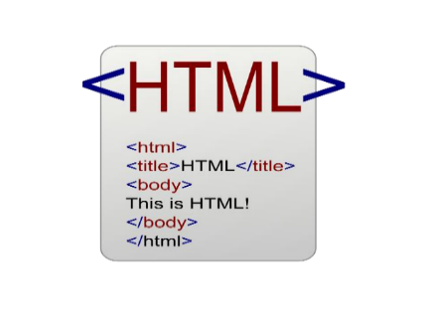

**Fig 3.1 HTML**

**3.2 CSS (Cascading Style Sheets)**

CSS (Cascading Style Sheets) is a fundamental style sheet language used to control the presentation of HTML and XML documents. Initially designed to separate content from design, CSS has become ahow elements should be displayed, CSS allows for a wide range of design possibilities, from simple color changes to complex animations and layouts.

One of the core features of CSS is its ability to apply styles to multiple elements simultaneously, reducing redundancy and ensuring a consistent look and feel across a website. CSS selectors, properties, and values provide a powerful syntax for targeting specific elements and applying styles. This flexibility is further enhanced by CSS preprocessors like Sass and Less, which introduce variables, nesting, and functions to streamline the development process and make stylesheets more maintainable.

Responsive design is a crucial aspect of modern web development, and CSS plays a vital role in achieving this. Media queries allow developers to apply different styles based on the characteristics of the user's device, such as screen size and resolution. This ensures that web pages are accessible and usable across a wide range of devices, from desktops to smartphones. Flexbox and Grid Layout are two advanced CSS layout modules that facilitate the creation of complex, responsive layouts without the need for floats or positioning hacks.

In addition to static styling, CSS also supports dynamic visual effects. Transitions, transforms, and animations enable developers to create smooth and engaging user experiences. These features can be used to animate element properties, rotate and scale elements, and create intricate animations, all while maintaining performance and responsiveness.



**Fig 3.2 CSS**

**3.3 Javascript**

JavaScript is a versatile, high-level programming language that is a core component of web development. Initially created to add interactive elements to websites, JavaScript has evolved into a powerful tool that can be used for a wide range of applications. This language enables developers to implement complex features such as dynamic content updates, interactive forms, multimedia handling, and much more, directly within the browser. Its ability to manipulate HTML and CSS makes it an essential part of the web development triad, alongside these other technologies.

One of the defining features of JavaScript is its event-driven nature, which allows it to respond to user actions such as clicks, form submissions, and keyboard inputs. This capability is crucial for creating a responsive user experience, where the web page reacts immediately to user interactions without needing to reload. JavaScript's asynchronous programming model, supported by features like callbacks, promises, and the async/await syntax, further enhances its ability to handle tasks such as data fetching and processing in the background, without blocking the main thread of execution.

Moreover, JavaScript is not limited to client-side scripting. With the advent of Node.js, JavaScript can now be used for server-side programming, making it possible to build entire applications using a single programming language across both the client and server environments. This unification simplifies the development process and allows for more seamless data exchange and logic sharing between the frontend and backend.



**Fig 3.3 JavaScript**

**3.4 PHP**

PHP (Hypertext Preprocessor) is a widely-used, open-source server-side scripting language designed specifically for web development. Initially created in 1994 by Rasmus Lerdorf, PHP has evolved into one of the most popular languages for building dynamic websites and web applications. PHP is embedded in HTML and executed on the server, allowing developers to generate dynamic web content based on user interactions, database queries, or other server-side processes.

PHP’s ease of use, flexibility, and ability to work seamlessly with databases like MySQL have made it a cornerstone of web development, especially for small-to-medium-sized websites and Content Management Systems (CMS) like WordPress, Joomla, and Drupal. PHP is platform-independent and can be deployed on almost any web server, such as Apache, Nginx, or Microsoft IIS, making it highly versatile.

One of PHP’s key strengths is its integration with a wide variety of databases, including MySQL, PostgreSQL, and SQLite, which allows developers to create powerful database-driven websites. PHP also supports numerous protocols, including HTTP, LDAP, and IMAP, and can be extended through thousands of available libraries, enabling developers to easily add functionality to their applications.



**Fig 3.4 Php**

**3.5 MySQL**

MySQL is an open-source relational database management system (RDBMS) developed by Oracle Corporation. Known for its speed, reliability, and ease of use, MySQL has become the database of choice for many web applications and platforms. It is particularly well-suited for applications where structured data needs to be stored, retrieved, and manipulated. MySQL follows the Structured Query Language (SQL) standard, which allows developers to interact with the database in a consistent manner.

MySQL is often paired with PHP in the development of dynamic web applications. The combination of PHP and MySQL (commonly referred to as the LAMP stack when combined with Linux and Apache) is one of the most widely used setups for web hosting, powering millions of websites and applications globally. MySQL provides support for large-scale web applications and is known for its high performance in high-traffic environments.

Technologies Used:

* Database Features:
  + Indexes and Keys: MySQL provides support for indexing and primary/foreign key relationships to enhance query performance and ensure data integrity.
  + Triggers and Stored Procedures: These features allow developers to automate repetitive database tasks and enforce business logic at the database level.
  + Replication: MySQL supports master-slave and master-master replication configurations, making it ideal for distributed applications and ensuring data redundancy.
* Data Security: MySQL includes features like SSL encryption, user roles, and permission control to enhance security in database management.
* Web Integration: MySQL seamlessly integrates with PHP for web application development. PDO (PHP Data Objects) and MySQLi (MySQL Improved) are commonly used to manage MySQL connections within PHP applications.
* High Availability Solutions:
  + MySQL Cluster: Provides a high-availability, high-redundancy architecture for mission-critical applications.
  + MySQL Replication: Ensures data is replicated between multiple MySQL instances, allowing load balancing and failover mechanisms.
* Backup Tools:
  + mysqldump: A utility that allows developers to back up their databases, ensuring data security.
  + MySQL Enterprise Backup: Provides incremental backup capabilities for enterprise-grade solutions.
* Query Optimization: MySQL offers EXPLAIN plans and query optimization tools that help developers optimize database queries for improved performance.
* IDEs and Management Tools:
  + MySQL Workbench: An official graphical interface tool for designing, developing, and administering MySQL databases.
  + phpMyAdmin: A web-based administration tool for managing MySQL databases, widely used in conjunction with PHP applications.
* Scalability: MySQL supports sharding (horizontal partitioning of data) and clustering solutions to scale applications as they grow, ensuring the database can handle increasing amounts of data and traffic.
* Data Types and Functions:
  + MySQL provides a rich set of data types (e.g., integers, floating-point numbers, dates, strings) and functions (e.g., string manipulation, date calculations, and aggregate functions) that support complex queries and data manipulation.



**Fig 3.5 Mysql**

When developing a car buying and selling website, MySQL plays a crucial role as the database management system, handling all the data storage and retrieval necessary for the platform's functionalities. MySQL helps organize and store various types of data, from user profiles and car listings to transaction details, ensuring the smooth functioning of the website. The database structure must be well-designed to accommodate the different aspects of the car sales process, including user accounts, car information, and communication between buyers and sellers.

The user data table is essential for storing information about the individuals using the platform. This includes both buyers and sellers, who will need to register with personal details such as name, email, password, contact information, and user type (buyer or seller). The car listings table will store data related to each car being sold, including the car's make, model, year, price, description, photos, and seller information. By linking this table with the user data table, the website can track which user is selling which car.

To provide a smooth and efficient user experience, MySQL's search and filter capabilities should be leveraged. For example, you might want to create an index on columns like car make, model, and price range, which allows for fast querying when buyers are searching for specific vehicles. The system should also support filtering by location, vehicle condition, and other parameters, enabling users to quickly find the cars that best match their needs.

***Chapter4***

**Implementation Details and Experimental Results**

The Feedback Form Design and Submission Module serves as the primary interface through which students interact with the system. It is the most essential component of the Online Feedback Form System, responsible for collecting structured input from students in a format that is both user-friendly and analytically useful. The design of this module was driven by the goals of simplicity, responsiveness, accessibility, and security, with an emphasis on preserving the anonymity and integrity of the feedback data.

**4.1 Feedback Form Design and Submission Module**

To begin with, the feedback module is designed to be web-based and platform-independent, enabling students to access the system from any device—be it a desktop, laptop, tablet, or smartphone—without requiring any installation or software dependency. The frontend is built using HTML5, CSS3, JavaScript, and optionally enhanced with responsive design frameworks such as Bootstrap. The layout is clean and minimal, featuring intuitive navigation and visual cues to guide users through the feedback process. Upon logging in securely using a unique student ID and password or verification code, students are directed to their dashboard, which displays active feedback sessions based on their academic profile. The dashboard interface is personalized, ensuring that only relevant forms are shown to each student, such as those corresponding to their enrolled courses or department. This avoids unnecessary confusion and minimizes the risk of incorrect submissions.

Once a student selects a feedback session, the system displays a dynamic form, which is generated based on a template configured by the administrator. Each feedback form typically consists of multiple sections, such as:

* Faculty and Teaching Feedback
* Course Content and Structure
* Laboratory and Infrastructure Evaluation
* Overall Learning Experience
* Suggestions and Open Comments

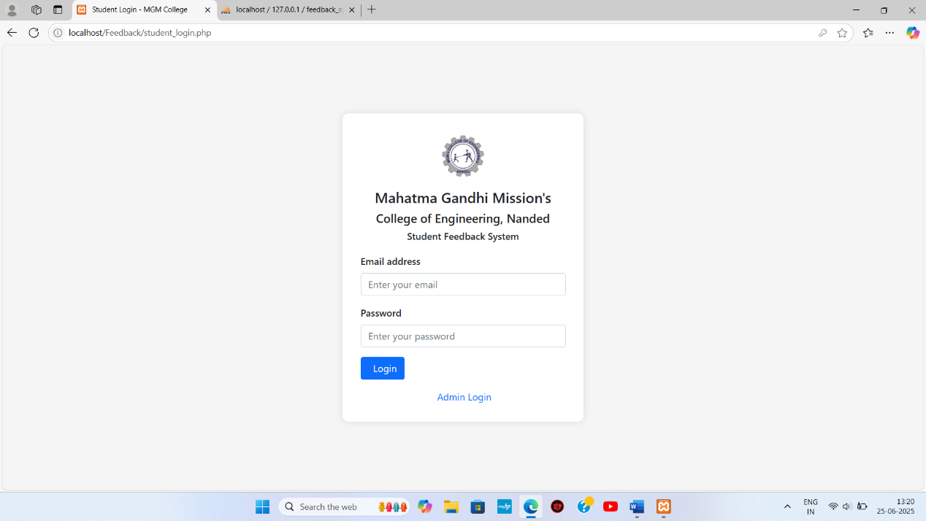

**Fig 4.1 Student Login**

In Fig 4.1 image shows the Student Login page of the feedback system hosted locally. Students are required to enter their email address and password to log in and access the feedback form. The page features a clean layout with the college logo and title: *"Mahatma Gandhi Mission's College of Engineering, Nanded - Student Feedback System"*. A link to switch to the admin login is also provided.

The questions within these sections are varied in type, including rating scale questions (usually on a 1–5 or 1–10 scale), multiple-choice questions, and open-ended text inputs. This hybrid format enables both quantitative and qualitative data collection. For example, a student may rate a teacher's punctuality as 4 out of 5 and also provide a written suggestion on improving engagement during lectures. This combination adds depth and detail to the feedback collected, giving administrators richer insights into the academic environment.

One of the important design features of the module is real-time form validation. JavaScript-based validation ensures that students do not accidentally submit incomplete or invalid responses. Fields marked as mandatory must be filled before submission is allowed. Error prompts are clearly displayed next to the fields requiring attention, and tooltips or help text may be added to guide students on how to interpret the questions. Moreover, the system prevents duplicate entries by disabling the form for a particular session once a student has successfully submitted feedback.

The submission process itself is optimized for reliability and security. When a student clicks on the submit button, the form data is passed to the backend through secure POST requests. The server then validates the session, confirms user eligibility, and saves the responses into the database. Each feedback submission is timestamped, and the session is locked to ensure the student cannot alter or re-submit their input. Confirmation of a successful submission is displayed on the screen, along with a message of appreciation for the student’s participation.

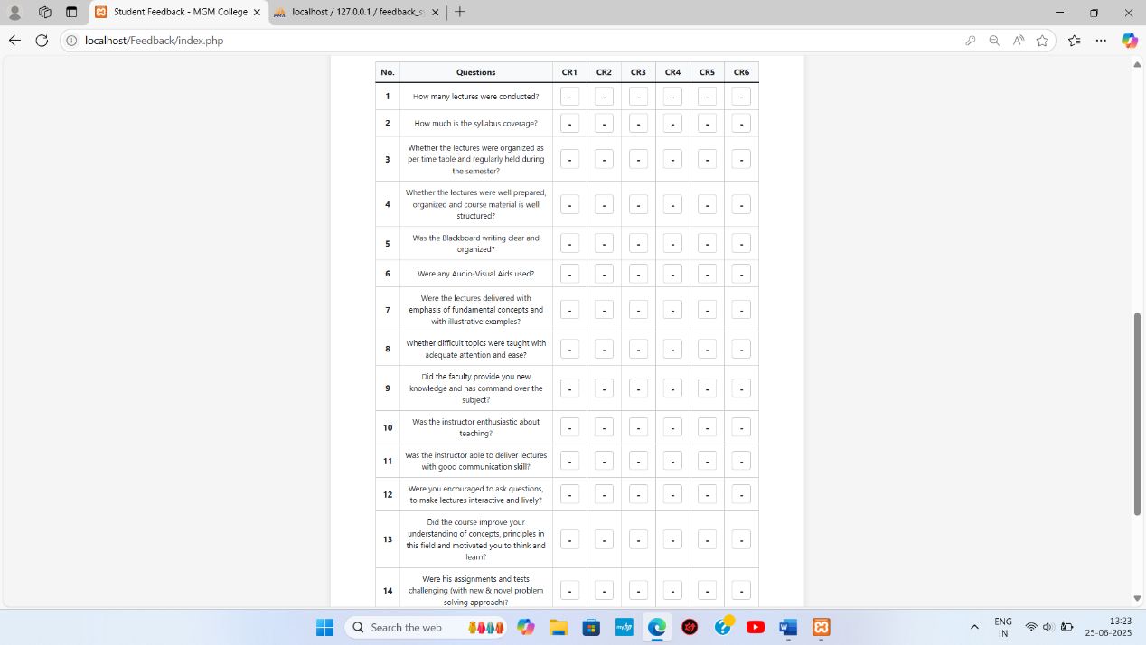

**Fig 4.2 Feedback Form**

In Fig 4.2 image displays the feedback form interface presented to students after logging in. It contains 16 questions, each aiming to evaluate different aspects of a teacher’s performance like syllabus coverage, use of audio-visual aids, enthusiasm, clarity, and communication skills. The form includes options for multiple course representatives (CR1 to CR6), allowing students to rate each teacher individually.

A key principle followed throughout the development of this module is anonymity. Student responses are stored in the database in such a way that they are not linked to personally identifiable information. This is achieved by generating anonymous tokens or by separating user identification and feedback records in different database tables. This approach greatly increases student confidence and encourages them to provide candid, meaningful feedback, especially when critiquing sensitive aspects such as teaching style or administrative efficiency.

**4.2 Administrator Panel and Dashboard Integration**

The Administrator Panel and Dashboard Integration is a central feature of the Online Feedback Form System for College Department. It is designed to empower department-level administrators, academic coordinators, or institutional feedback controllers with a powerful, intuitive interface to manage, monitor, and extract value from the student feedback process. Unlike the student-facing modules that focus on data input, the admin panel is geared toward system configuration, user control, feedback form design, session scheduling, and analytics generation, making it the operational backbone of the entire system.

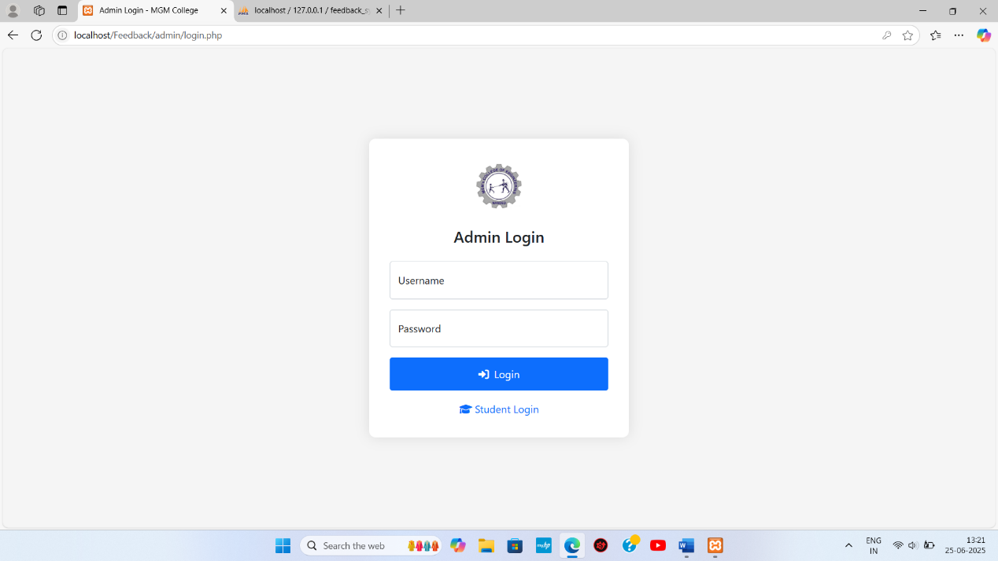

**Fig 4.3 Admin Login**

In Fig 4.3 image, the Admin Login page is shown. Admins can access the administrative functions of the system by entering their username and password. The layout mirrors the student login page for design consistency and includes a switch link to return to the student login interface. This ensures secure and role-based access to different parts of the system.

The administrator panel begins with a secure, role-restricted login interface, ensuring that only authorized personnel can access critical system functionalities. Login credentials are encrypted using secure hashing algorithms, and login attempts are monitored to prevent unauthorized access. Once inside, administrators are presented with a multi-tabbed dashboard, categorized for functional clarity—typically including tabs such as “Manage Forms,” “View Submissions,” “Create Sessions,” “Analytics,” “Reports,” and “Settings.”

One of the core capabilities of the admin panel is feedback form management. Administrators can create and configure feedback forms tailored to specific courses, departments, academic years, or faculty members. Using an embedded form builder interface, the administrator can add, edit, or remove questions; assign them to specific categories such as “Faculty Performance” or “Course Relevance”; and choose the input types (e.g., rating scales, dropdowns, text fields). The system also supports the use of pre-defined templates, which can be reused or modified for future sessions. This design flexibility ensures that the feedback process remains adaptable to changing academic requirements and institutional policies.

Another essential feature is session management, which allows administrators to define feedback periods for specific groups of students. For example, feedback sessions can be opened for final-year students of the Computer Science department for a defined window say, from March 1st to March 10th. During this time, only eligible students will be able to view and submit feedback forms. After the session closes, the system automatically locks submissions, ensuring data consistency. Admins can also set reminders and monitor live participation stats from the same dashboard, allowing for timely interventions to improve response rates.

The admin panel also supports student user management, either through manual entry or bulk import using CSV or Excel files. This includes mapping students to their respective departments, academic years, and courses, so that each user only accesses the feedback forms relevant to them. The system includes validation checks to avoid duplicate records, incorrect mappings, or missing information. For privacy and security, sensitive user data is protected and only visible to super-admins with elevated privileges.

One of the most powerful components of the admin interface is the real-time analytics dashboard. Once a feedback session concludes, the system aggregates student responses and presents key insights through interactive visualizations. This includes question-wise average ratings, department-wise performance comparisons, and trend charts over time. Administrators can filter results by academic year, course code, or session ID, allowing for granular analysis. Visual tools such as bar charts, pie charts, and radar graphs are integrated using libraries like Chart.js or Google Charts, offering an intuitive view of student sentiments and performance metrics.

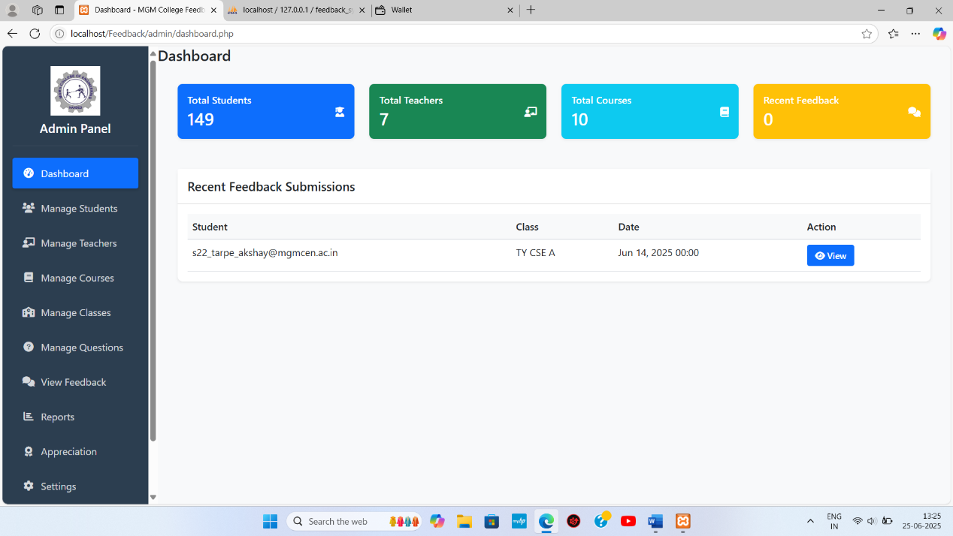

**Fig 4.4 Admin Dashboard**

In Fig 4.4 image shows the Admin Dashboard where key statistics are displayed, including the total number of students (149), teachers (7), courses (10), and a section for recent feedback submissions. One feedback submission is listed with student email, class, and date. The left sidebar contains navigation links for managing students, teachers, courses, classes, questions, and reports.

The dashboard also includes tabular breakdowns that display the exact number of responses per question, number of students who skipped certain questions, and the highest and lowest rated parameters. Open-ended responses are stored separately and can be viewed in bulk for qualitative review. While sentiment analysis or keyword tagging is outside the scope of the current version, the interface is designed to accommodate such features in future updates.

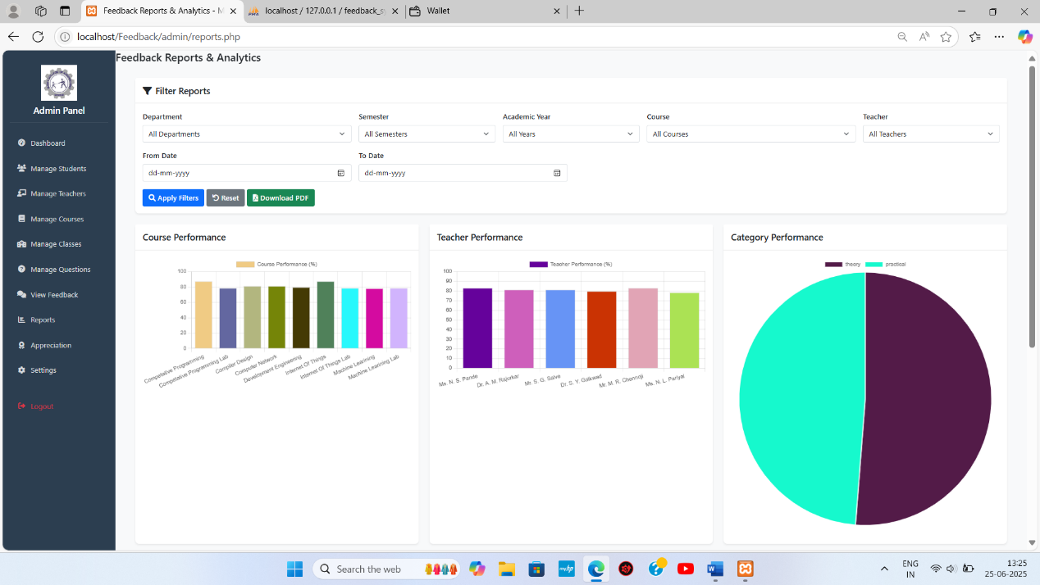

**Fig 4.5 Feedback Reports & Analytics**

In Fig 4.5 image features the Reports & Analytics section where feedback data is visualized using bar charts and a pie chart. Admins can apply filters such as department, semester, academic year, course, and teacher. The three types of analytics shown are: Course Performance, Teacher Performance, and Category Performance (theory vs practical). There is also an option to download the report as PDF.

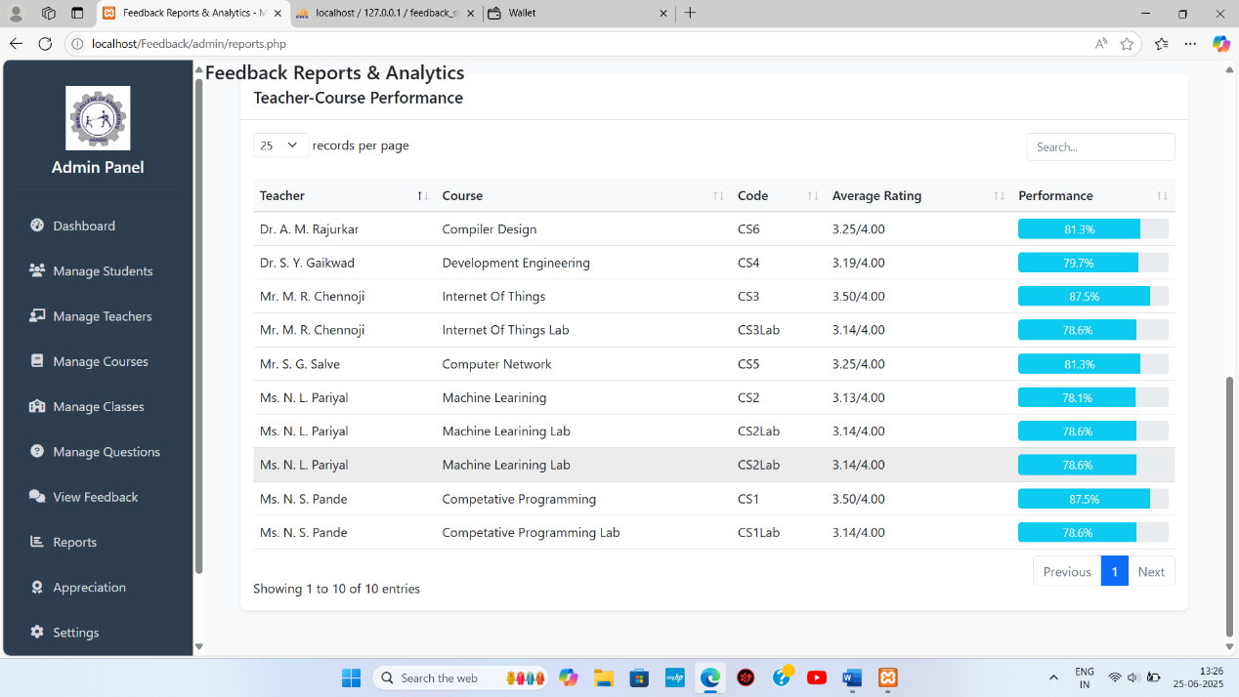

**Fig 4.6 Teacher-Course Performance Table**

In Fig 4.6 image displays a detailed Teacher-Course Performance table, listing all courses taught along with their respective teacher, course code, average rating out of 4.00, and calculated performance percentage. For example, "Dr. A. M. Rajurkar" for "Compiler Design" received a rating of 3.25/4.00 with a performance score of 81.3%. This view helps the admin analyze which teacher or course is performing well or needs improvement.

Administrators can also generate automated reports from the dashboard. These reports summarize all feedback metrics in a structured format and are exportable as PDF, Excel, or CSV files. This is particularly useful for accreditation reviews, internal audits, and academic meetings. Reports can include timestamps, session metadata, and even institutional branding for official documentation. Custom headers, watermarks, and summaries can be added to align reports with college requirements.teacher.

To maintain system integrity and data accuracy, the admin panel includes an activity log module, which records all actions performed within the system, such as form creation, session scheduling, report downloads, and user management. These logs help in troubleshooting and ensure accountability in administrative operations. Access controls are granular, meaning different admins can be given different levels of privileges—some may only create forms, others may access analytics, while only super-admins can edit user records or change system settings.

**4.3 Database Design and Implementation**

The Database Design and Implementation phase plays a critical role in the overall success and efficiency of the Online Feedback Form System for College Department. The database serves as the foundation for data integrity, secure storage, fast retrieval, and scalable analytics. Given the dynamic nature of feedback forms, the diversity of user types, and the volume of data generated during each session, it was essential to design a database architecture that is not only normalized and relational but also adaptable to future enhancements and expansion.

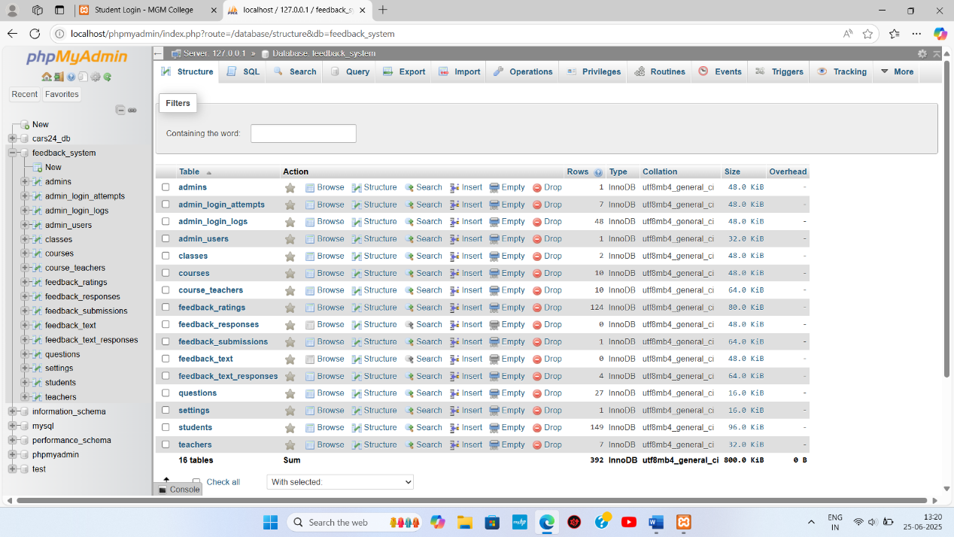

**Fig 4.7 Database Design**

In Fig 4.7 image displays the phpMyAdmin interface showing the database named feedback_system, which contains 16 tables such as admins, students, teachers, courses, feedback_responses, and questions. These tables are the backbone of the feedback system, storing login credentials, class details, feedback entries, and response data. The database uses InnoDB as the storage engine and utf8mb4_general_ci collation for character support.

The database structure is organized into a well-normalized schema with multiple interconnected tables, each designed to handle a distinct component of the system. The key tables include:

* Students Table (students):

This table stores essential information about students, such as student ID, full name, department, academic year, and login credentials (hashed passwords or OTP tokens). While students provide feedback, their identities are anonymized in the feedback table to protect privacy. This table is only used for authentication and eligibility mapping.

* Feedback Forms Table (forms):

This table stores metadata about the feedback forms created by the admin. Each record includes a unique form ID, form title, department, target semester, and session status (active, upcoming, or closed). The table also links to the questions table to define the structure of the feedback form.

* Questions Table (questions):

This table contains the actual feedback questions, each tagged with a type (e.g., rating scale, multiple-choice, text response), category (e.g., faculty performance, infrastructure), and order index to ensure proper display sequence. Each question is linked to a specific form ID and can be reused across different forms if needed.

* Responses Table (responses):

The most critical table in the database, responses stores the actual feedback data submitted by students. Each entry records the response ID, question ID, form ID, session ID, response value (numeric rating or text), timestamp, and anonymized student token (if required). To ensure privacy, no direct linkage to student identity is stored in this table unless permitted under strict institutional rules.

* Admins Table (admin_users):

Stores credentials and role details for system administrators. Each record includes admin ID, name, email, hashed password, role type (super admin, department admin), and activity log references.

* Activity Logs Table (logs):

This audit trail table tracks system events such as login attempts, form creation, submission timestamps, report exports, and any configuration changes. It ensures system transparency, traceability, and accountability.

To ensure data consistency, the database adheres to third normal form (3NF). This eliminates redundant data and promotes referential integrity across tables using foreign key constraints. For instance, each response in the responses table references both a question_id and form_id, which in turn refer back to their parent entries in the questions and forms tables respectively.

For performance optimization, indexing strategies have been implemented. Fields such as question_id, form_id, and student_id are indexed to accelerate query performance, especially during analytics generation where thousands of responses are processed. Composite indexes are used in some queries, particularly for dashboard filters like "average score per department per session," which involve multi-table joins.

**4.4 Testing and Experimental Results**

The Testing and Experimental Results phase is one of the most critical stages in the development lifecycle of the Online Feedback Form System for the College Department. Given the system’s role in collecting, storing, and analyzing feedback data across various departments and academic sessions, it is imperative to ensure that the platform performs reliably under a wide range of real-world conditions. This section outlines the systematic approach taken for testing, the types of tests performed, the results obtained, and the overall impact of testing on system readiness and reliability.

To ensure thorough validation, a multi-layered testing methodology was adopted that included unit testing, integration testing, system testing, usability testing, and performance testing. These tests were executed in iterative phases parallel to development, following the Agile approach, allowing for continuous feedback and early resolution of issues. Each module—such as student login, feedback form handling, response recording, session scheduling, and report generation—was tested independently and then in conjunction with other modules to simulate real operational flow. Unit testing was performed at the code level to validate the smallest functional components in isolation. Functions such as input validation, session expiry handling, duplicate submission detection, and response sanitization were tested with various valid and invalid inputs. For instance, in the feedback submission module, unit tests ensured that users could not submit incomplete forms, could not bypass required fields, and could not resubmit after a successful submission. JavaScript-based client-side validations were cross-tested with server-side revalidations to ensure consistency and prevent manipulation through developer tools or scripts.

Integration testing evaluated the interaction between system modules, particularly between the frontend and backend, and between the backend and the database. This was crucial for confirming that student responses were correctly stored, session states were updated, and reports were generated accurately. Test cases included scenarios such as: “Submit a form with all valid inputs,” “Attempt to submit after the session ends,” “Check if data appears correctly in the admin dashboard,” and “Test if the feedback summary updates live upon each new submission.” These tests confirmed that API endpoints were functioning correctly and that session data integrity was preserved even under concurrent access by multiple users.

System testing was carried out in a simulated production environment to assess the complete system behavior. A testing server hosted the deployed version of the application, and a dummy database with thousands of test records was used to emulate a real college environment. Different roles (admin, student) were tested on various devices and browsers to ensure that the system responded uniformly. Emphasis was placed on edge cases such as sudden browser refreshes during submission, multiple tab activity, back-button navigation after submission, and accidental duplicate logins. These tests proved that the system was resilient and could handle such unexpected behaviors gracefully without crashing or corrupting data.

Usability testing was conducted with a sample group of 30 students and 3 department administrators who were asked to interact with the platform as they would in a real setting. Students found the feedback form intuitive and easy to complete, averaging around 4 minutes per submission. The anonymity of responses and the clarity of form questions were particularly appreciated. Admin users reported that the form creation interface and analytics dashboard were straightforward, requiring minimal training to operate. Suggestions gathered from this group included adding tooltips to explain rating scales, improving color contrast for better accessibility, and enabling sorting/filtering of analytics data—all of which were incorporated into the final version.

**Conclusion**

The development of the Online Feedback Form System for College Department represents a significant step forward in the digital transformation of academic quality assurance processes. In traditional settings, the collection and analysis of student feedback have often been constrained by inefficiencies, time delays, human errors, and low participation rates. Manual systems are not only resource-intensive but also prone to subjective interpretation and bias, undermining the primary purpose of gathering constructive insights. This project, therefore, addresses a very real institutional need by replacing outdated feedback mechanisms with a modern, secure, and scalable web-based solution that leverages the strengths of technology to enhance transparency, responsiveness, and educational improvement.

Throughout the course of this project, the system was designed and implemented with a clear vision—to streamline and strengthen the student feedback process through automation, standardization, and intelligent data processing. It has been built using robust backend technologies like MySQL and PHP/Python, integrated with dynamic and responsive front-end frameworks, enabling a seamless experience for both students and administrators. The system supports role-based access, form customization, anonymous response collection, real-time analytics, and report generation—functions that are essential for timely and evidence-based academic decision-making.

From the student perspective, the platform ensures accessibility, simplicity, and privacy. Students can log in securely, access only the feedback sessions relevant to them, and submit structured and unstructured feedback without fear of identification. This anonymity fosters greater honesty and engagement, thereby improving the quality and usefulness of the data collected. The validation mechanisms and single-attempt submission rules further enhance the integrity of the feedback data. Meanwhile, the administrator panel equips academic staff with powerful tools to create feedback forms, define session timelines, monitor participation, and generate graphical and tabular reports. These features dramatically reduce administrative overhead and enhance the ability to act on feedback promptly.

**REFERENCES**

**[1]** V. Rajaraman, “*Fundamentals of Computers,*” 6th Edition, PHI Learning Pvt. Ltd., New Delhi, 2014.

**[2]** Pressman, R. S., “*Software Engineering: A Practitioner’s Approach,*” 7th Edition, McGraw Hill Education, 2014.

**[3]** Sommerville, I., “*Software Engineering,*” 10th Edition, Pearson Education, 2016.

**[4]** Elmasri, R., & Navathe, S. B., “*Fundamentals of Database Systems,*” 7th Edition, Pearson Education, 2017.

**[5]** Silberschatz, A., Korth, H., & Sudarshan, S., “*Database System Concepts,*” 6th Edition, McGraw Hill, 2011.

**[6]** Welling, L., & Thomson, L., “*PHP and MySQL Web Development,*” 5th Edition, Addison-Wesley, 2016.

**[7]** Flanagan, D., “*JavaScript: The Definitive Guide,*” 6th Edition, O’Reilly Media, 2011.